**Ideation Phase**

**Define the Problem Statements**

|  |  |
| --- | --- |
| Date | 01 November 2023 |
| Team ID | NM2023TMID04457 |
| Project Name | BUILDING A WEBSITE USING CANVA |

**Customer Problem Statement Template:**

Customers who enjoy spending time in coffee shops while reading books often face challenges in finding the ideal environment that caters to their specific needs and preferences**.**

Our coffee shop with a reading book theme aims to provide a tranquil and inviting atmosphere for book enthusiasts. Designated areas with minimal noise to allow customers to focus on their books. Comfortable chairs and seating arrangements designed for extended reading sessions.

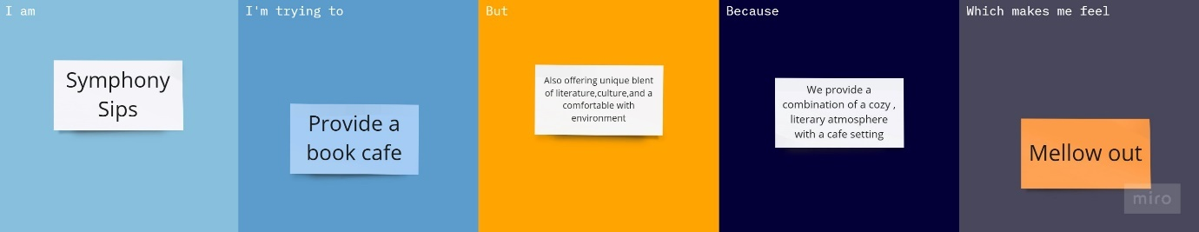

|  |  |  |  |  |  |
| --- | --- | --- | --- | --- | --- |
| **Problem Statement (PS)** | **I am (Customer)** | **I’m trying to** | **But** | **Because** | **Which makes me feel** |
| PS-1 | Noise Disturbance | Find that may I be bothered by noise from other patrons, loud conservation or disruptive behaviour | Maintain a welcoming and peaceful environment | The wrong reviews are given | The quiet and peaceful environment can encourage introspection and deep thinking. |
| PS-2 | Book Availability | Encounter the cafe has a limited book selection or lacks specific titles. | It does not disappoint customers | The ambiance is cozy , and the book selection is fantastic. | Many people feel grateful for having a place that combines their love for books and a relaxing environment |